Blowhorn has been featured in various media portals, both online and offline. Here are some snippets about our coverage since the inception of Blowhorn.

Tech and Business Websites:
- Yourstory
https://yourstory.com/2018/04/blowhorn-impressed-the-man-who-funded-skype-tesla-and-spacex/
https://yourstory.com/2018/12/top-20-startup-stories-2018/
https://yourstory.com/2018/05/pitch-got-blowhorn-3-8-m-tim-draper-investors/

- Entrepreneur India
https://www.entrepreneur.com/article/315917
https://www.entrepreneur.com/article/327279

- VC Circle
https://www.vccircle.com/msdf-pumps-fresh-capital-into-logistics-marketplace-blowhorn/
Live Mint: https://www.livemint.com/Leisure/MS4iemJeFhlO5x3phJLOwO/New-ways-to-meet-In-a-park-or-a-traffic-jam.html
Bloomberg Quint
https://www.bloombergquint.com/technology/startup-street-why-the-future-of-bengalurus-startup-ecosystem-may-be-under-threat

Daily:
- Times of India: http://timesofindia.indiatimes.com/articleshow/64029043.cms?utm_source=contentofinterest&utm_medium=text&utm_campaign=cppst

Financial Daily:
- Economic Times:
https://economictimes.indiatimes.com/wealth/earn/startup-blowhorn-helps-individuals-transport-goods-within-the-city/articleshow/63947266.cms

Magazines
- Analytics India:
https://analyticsindiamag.com/industry-views-niti-aayogs-ai-strategy-report/
- Overdrive:
http://overdrive.in/news-cars-auto/pressreleases/tech-logistics-start-up-blowhorn-turns-electric-evs-to-make-up-50-of-fleet/

Some of the recognition received from Blowhorn’s esteemed customers:

AMAZON:

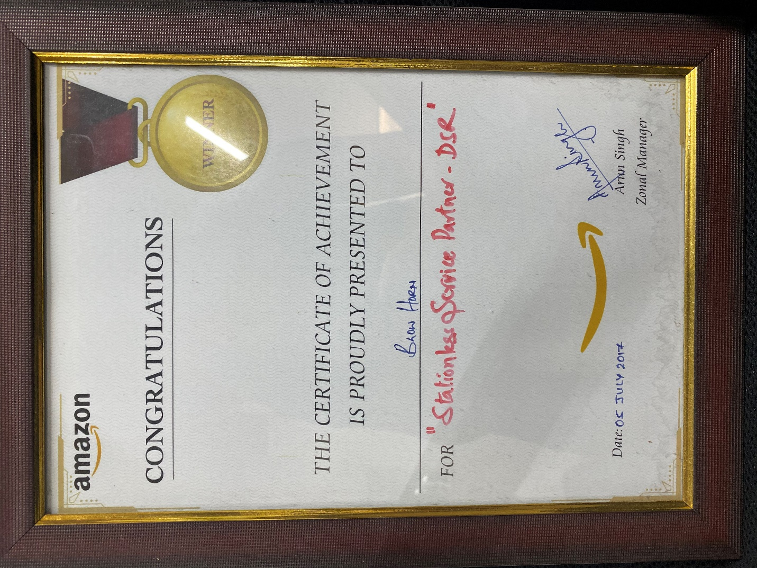
Image 1: Winner in the "Stationless Service Partner - DSR" category awarded by AMAZON

FLIPKART:

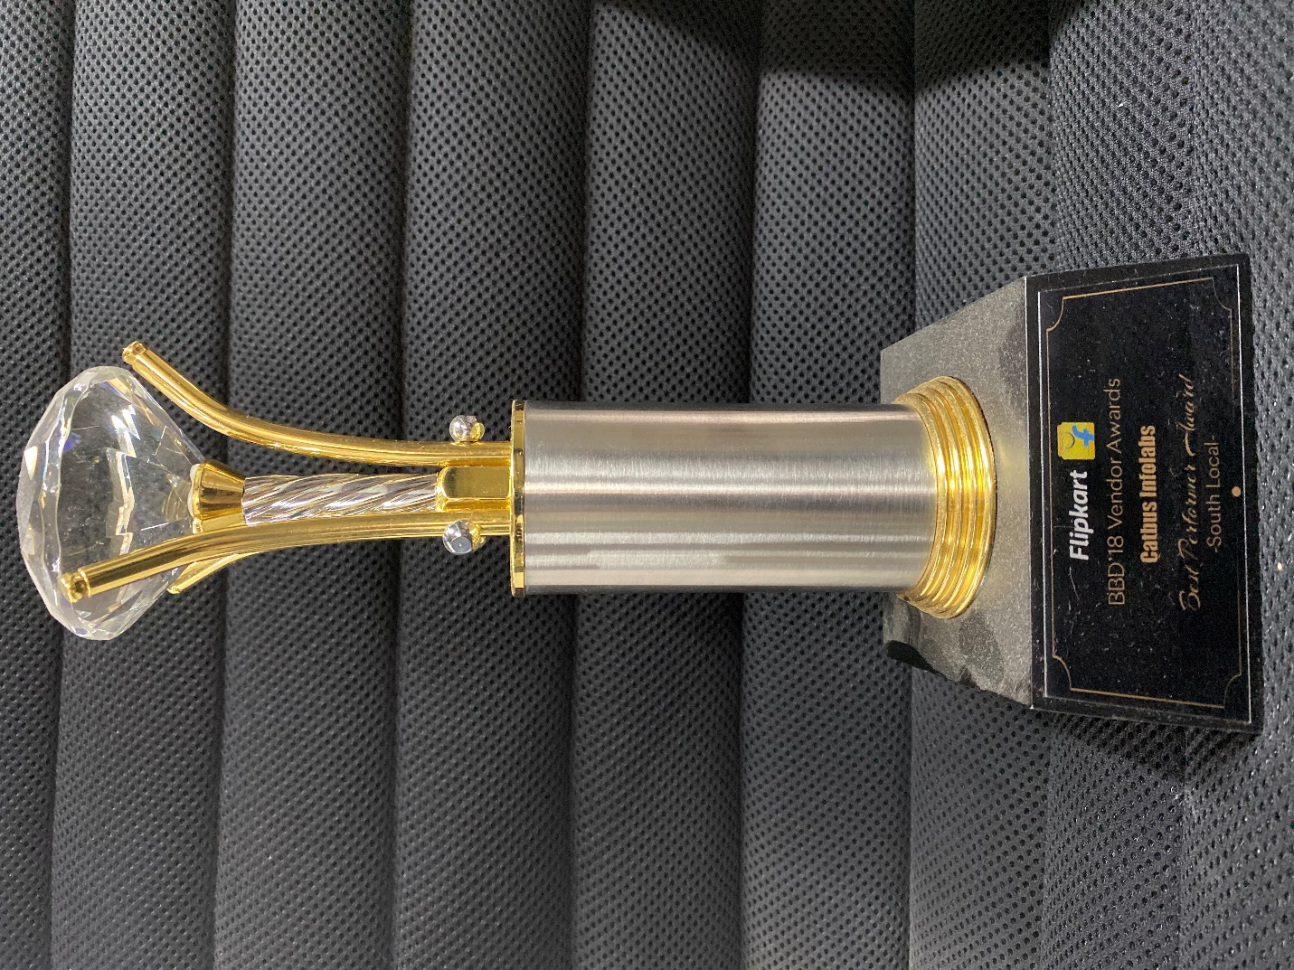
Image 2: Was awarded as the "Best Performer - South Zone" at BBD'18 vendor awards by Flipkart.

