Why BOLD?
The ‘Airbnb of boats’, Borrow A Boat, Britain’s leading boat rental and yacht charter marketplace, is part of the vanguard of companies digitising the large and maturing global charter market, set to be worth $30bn annually by 2027. One of the pioneers of peer-to-peer charter since 2017, Borrow A Boat is on a mission to make boating more accessible, affordable, flexible, and inclusive for all, to help drive participation, and make chartering a boat simpler.

In November, Borrow A Boat, secured £1,056,264 in investment from 916 investors, surpassing their £750,000 target by £306,264, and paving the way for the team to explore a potential initial public offering (IPO) in 2022 – a world first for a boat charter marketplace.

Project Description:

Amidst the backdrop of the global pandemic Borrow A Boat, Britain’s leading boat rental and yacht charter marketplace, set out to secure £750,000 in funding to build for further growth in 2022 and continued global expansion.

Founded in 2016 and launched in 2017 by entrepreneur Matt Ovenden, Borrow A Boat has grown rapidly since formation, with the team having previously raised over £3.8million in capital from a mix of crowdfunding, private investors, and venture capital investors.

On a mission to make boating more accessible, affordable, flexible, and inclusive, Borrow A Boat pioneered peer-to-peer boat charters, helping boat owners generate extra income from their vessels and reducing the high costs of boat ownership, including maintenance costs and marina fees, whilst offering consumers more affordable and flexible boating experiences. Borrow A Boat now has access to over 35,000 vessels in 65+ countries and offers both peer-to-peer listings as well as boat rental through traditional charter companies.

Strategy:

Borrow A Boat began their fourth crowdfunding raise with the aim of raising £750,000 to fuel further growth.
By using the Southampton Boat Show, one of the largest boat shows in Europe, to announce the intent for a fourth crowdfunding campaign, Borrow A Boat was able to appeal to likeminded investors with a launch event and talks, as well as combined offers for customers to receive discounted charters should they invest in the company. Those investing £500 or more received 5% off a charter up to £10,000 in value, and those investing upwards of £2,000 received 5% off any charter - meaning potential discounts of more than £5,000 on selected charters.

This encouraged investors by appealing to their boating interest and rewarding their investment with an opportunity to try out the platform for themselves.

Creative:

The campaign was supported by a video that introduced investors to the Borrow A Boat team, including CEO Matt Ovenden. This video summarised the pioneering work Borrow A Boat had already done in the boating industry, as well as the promising opportunities for investors should they choose to ‘get on board’ with Borrow A Boat.

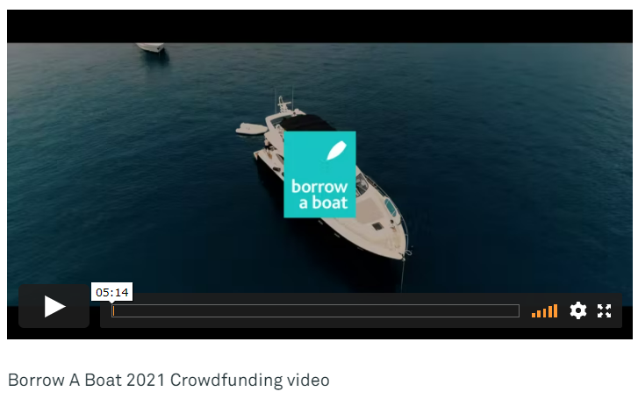
Link to video: https://vimeo.com/599683232/53d9b0aa71

PR:

From the outset the campaign was backed by a strong press campaign, with media updated at each major milestone of the campaign, resulting in more than 25 pieces of coverage secured in key national, business, tech and trade titles including the Financial Times, PhocusWire, Business Leader and Boat International. Media coverage was subsequently drip-fed to both investors and potential investors, to help build momentum for the funding round.

All crowdfunding coverage to date can be found via our digital Coverage Book here.

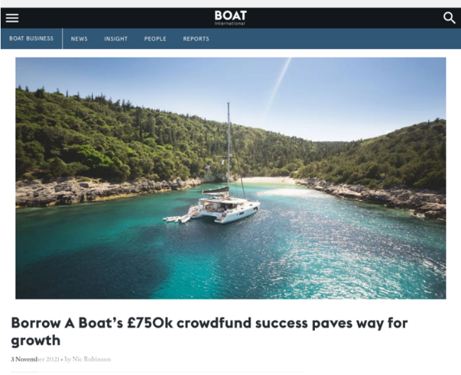
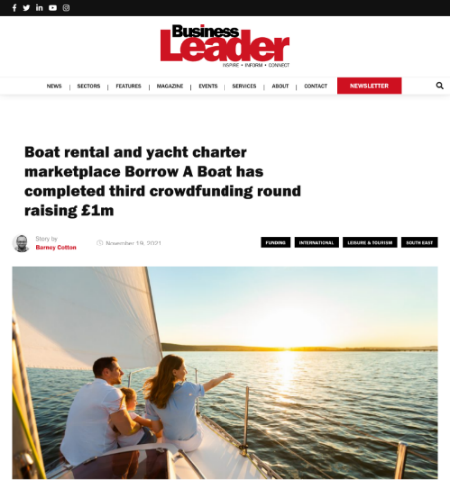

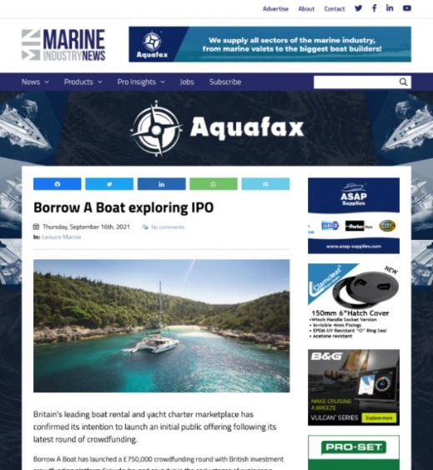
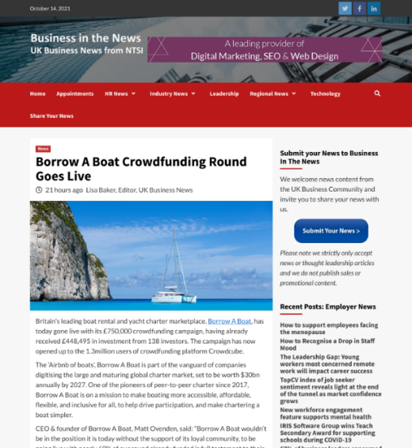

Timeline:

10th September – Announcement
Following accelerating growth and revenues in 2021, Borrow A Boat took the plunge and announced their crowdfunding campaign at the Southampton International Boat Show, Britain’s biggest festival of boating.

11th October – Launch
With £448,495 in investment already secured from 138 investors – testament to the unwavering support of Borrow A Boat’s loyal community - the crowdfunding campaign went live on 11th October, opening up to the 1.3million users of British investment crowdfunding platform Crowdcube.

2nd November – Target Smashed
On 2nd November 2021 and with eight days still to go, Borrow A Boat sailed past their funding target securing over £750,000 from 686 investors marking a major milestone in this crowdfunding journey.

Challenges

One of the big challenges faced during this campaign was appealing to investors to invest in a boating company amidst the backdrop of a pandemic.

Borrow A Boat overcame this challenge by providing detail of the rebounding market, using examples of growth to date to forecast the increasing popularity of the boating industry, whilst illustrating the rapid growth of the company, as well as the steps taken during the pandemic to ensure the company’s continued success. This included tech improvements, product development and digital marketing optimisations in 2020 and throughout 2021.

Results:

The team successfully completed their round on 18th November, having added an additional 7 days to the campaign to meet investor demand, with £1,056,264 in investment secured from 916 investors – an overinvestment from the Crowdcube community of £306,264. In addition, the 1,700 existing investors, from previous funding rounds, were offered an exit.

The Future:

After expansion into several new countries including the US, France, Germany, and Italy, as well as the acquisition of competitor and high-end charter brokerage, Helm, Borrow a Boat has cemented their position as the largest yacht charter marketplace in the UK as well as one of the leading yacht charter marketplaces globally. The team are now planning to IPO in 2022, which will be a world first for a boat charter marketplace.

The funds raised from this campaign will also allow for further expansion and acquisition in 2022, we are looking to make boating more accessible globally, and this means bringing our product to new markets worldwide.

For more information on Borrow A Boat visit: www.borrowaboat.com

For further press information contact:

Rosie Crass | Olivia Hazelden-Kingdon | Elsa Findlay
Rooster PR
T: +44 (0) 20 3440 8930
E: BorrowABoat@rooster.co.uk
W: www.rooster.co.uk

